ASSIGNMENT ON DIGITAL MARKETING

|  |  |
| --- | --- |
| **NAME** | ANUSHA U |
| **REGISTER NUMBER** | 953220106003 |
| **NM_ID** | DF50D63405784D5A0DB442CE295475C6 |
| **CATEGORY** | DIGITAL MARKETING |

**1. Create a blog or website using Blogspot or WordPress. Customize the theme design and post new article with 500 words.**

|  |  |
| --- | --- |
| **WEBSITE NAME** | Boutique Shop |
| **WORDPRESS URL** | [Boutique shop(wordpress.com)](https://dailyyfood.wordpress.com/) |
| **BLOG URL** | elaganza02boutique.blogspot.com/ |

Screenshots

**.**



**2. Create a New Facebook Business Page and post one social media poster for your brand.**

|  |  |
| --- | --- |
| **BRAND NAME** | CAAS GROCERY SHOP |
| **FACEBOOK PAGE URL** | https://www.facebook.com/caasgrocery |
|  |  |

**Home page**

**POST-1**

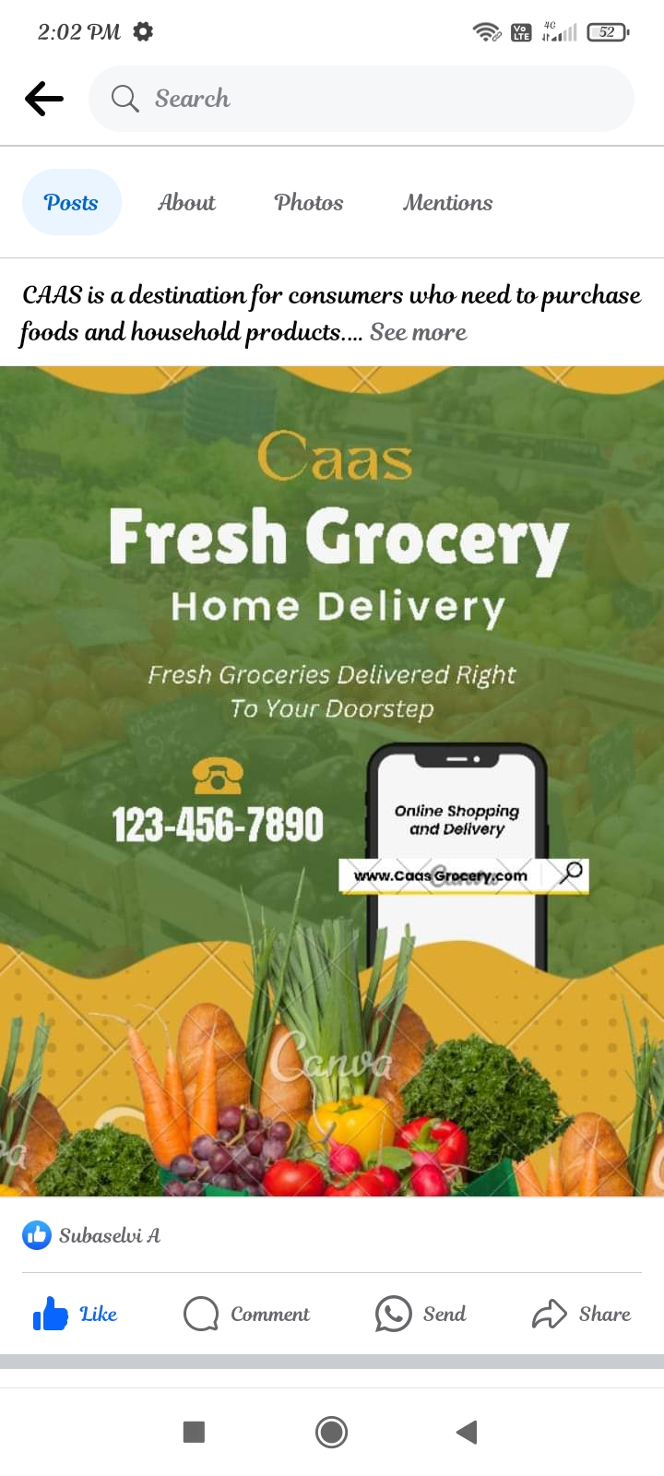

**3. Create and design a social media advertisement poster using canva.**

|  |  |
| --- | --- |
| **POST URL** | https://www.facebook.com/caasgrocery |

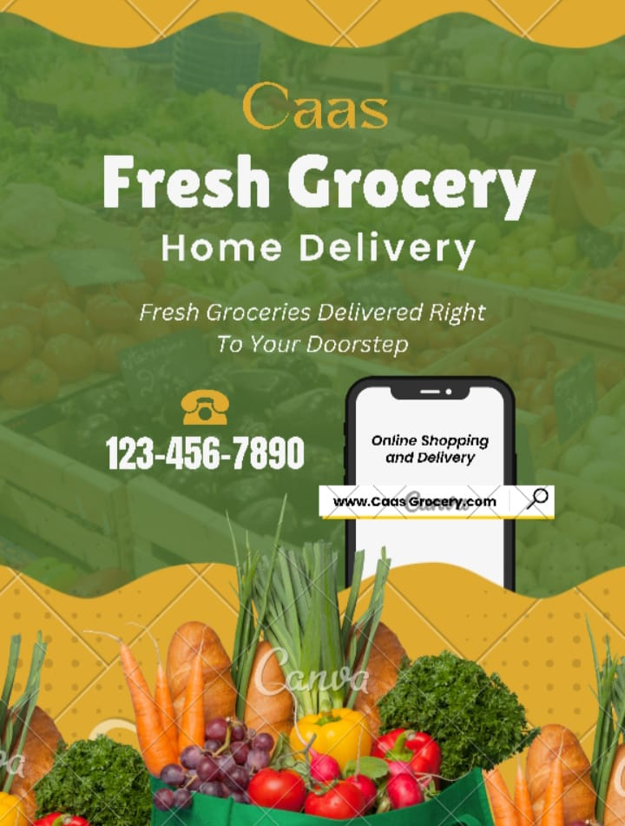

**4. Create email newsletter design using MailChimp or canva tool**

|  |  |
| --- | --- |
| **EMAIL NEWS LETTER URL** | **https://elaganza02boutique.blogspot.com** |

